# Contestant Program Book Information Form

## Contestant Information

|  |  |
| --- | --- |
| **Preferred Name:** |  |

|  |  |
| --- | --- |
| **Title:** |  |

|  |  |  |  |
| --- | --- | --- | --- |
| **Phone:** |  | **Email:** |  |
|  |
| **Talent:** |  | **Music Title:** |  |

|  |  |
| --- | --- |
| **Platform:** |  |
| **School:** |  |
| **Fleur de Lis Princesses:** |  |
|  |  |
|  |  |
|  |  |
|  |  |
|  |  |
|  |  |

## Ad Sales Information

|  |  |  |  |
| --- | --- | --- | --- |
| **Number of Full Pages:** |  | **Number of Ad Sales:** |  |
| **Total Amount $** |  |

|  |
| --- |
|  |
| |  |  |  |  |  |  | | --- | --- | --- | --- | --- | --- | | **Additional Notes:** |  |  |  |  |  | |  |  |  |  |  |  | |  |  |  |  |  |  | |  |  |  |  |  |  | |  |  |  |  |  |  | |  |  |  |  |  |  | |  |  |  |  |  |  | |
|  |
|  |
|  |

## Ad Sales Information

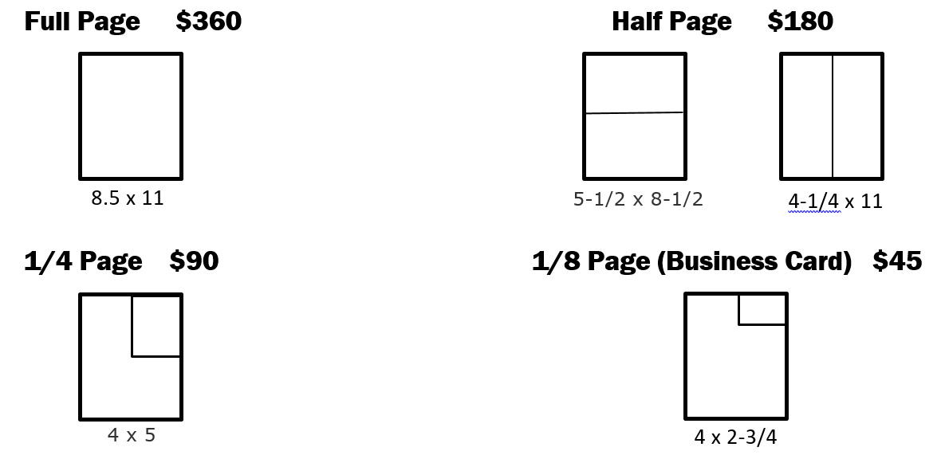

Pages Total

2 Pages (Minimum) ____________ $720

3 Pages __________________ $1080

4 Pages __________________ $1440

5 Pages __________________ $1800 Ad Sales Initiative

6 Pages __________________ $2160 $50

7 Pages __________________ $2520 $100

8 Pages __________________ $2880 $150

9 Pages __________________ $3240 $250

10 Pages __________________ $3600 $300

11 Pages __________________ $3960 $350

12 Pages __________________ $4320 $400

13 Pages __________________ $4680 $450

14 Pages __________________ $5040 $500

15 Pages __________________ $5400 $550

16 Pages __________________ $5760 $600

17 Pages __________________ $6120 $650

18 Pages __________________ $6480 $700

19 Pages __________________ $6840 $750

20 Pages __________________ $7200 $800

21 Pages __________________ $7560 $850

22 Pages __________________ $7920 $900

23 Pages __________________ $8280 $950

24 Pages __________________ $8640 $1000

25 Pages __________________ $9000 $1050

26 Pages __________________ $9360 $1100

27 Pages __________________ $9720 $1150

28 Pages __________________ $10080 $1200

29 Pages __________________ $10440 $1250

30 Pages __________________ $10800 $1300