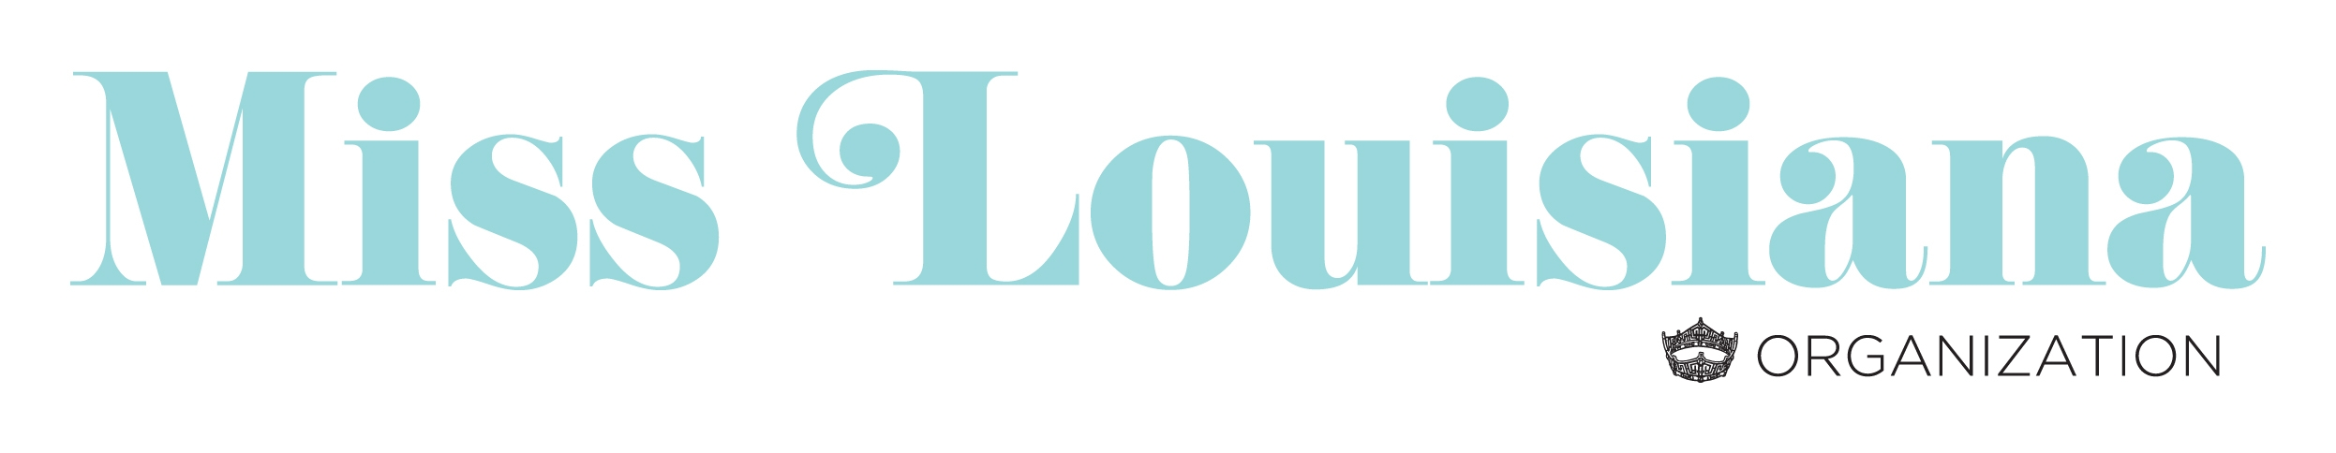
Directors Checklist

Local Preliminary Checklist

_____ All contestants registered on Children’s Miracle Network Hospital website
The following information should be completed immediately following your preliminary and emailed to:

Debbie Wyatt @ debbwyatt@hotmail.com

______ Miss Local Pageant Report

______ Scholarship Report

______ New Titleholder Information Report

______ Completed Local Preliminary Contestant List

______ Headshot or Crown Photo of New Titleholder for Website

The following documents should be mailed within 7 days to:
Miss Louisiana Scholarship Organization
Attn: Debbie Wyatt
1800 Forsythe Avenue
Suite 2, Box 306
Monroe, Louisiana 71201

______ Sealed Envelope Containing–Judges Individual Score Sheets & Tally
Sheets

_______Judges Signed Affidavits scan & email to Debbie

______ Copy of Titleholders signed Local Contestant Contract

______ Titleholder Certification of Eligibility to Compete (signed by director)

______ Assign Winner on Children’s Miracle Network Hospital website

______ Franchise Fee ($300.00) payable via PayPal

If you have any issues or questions concerning the judging process please contact one of the individuals listed below:

Dewana Little: (318) 376-2441 Debbie Wyatt (318) 680-2481

