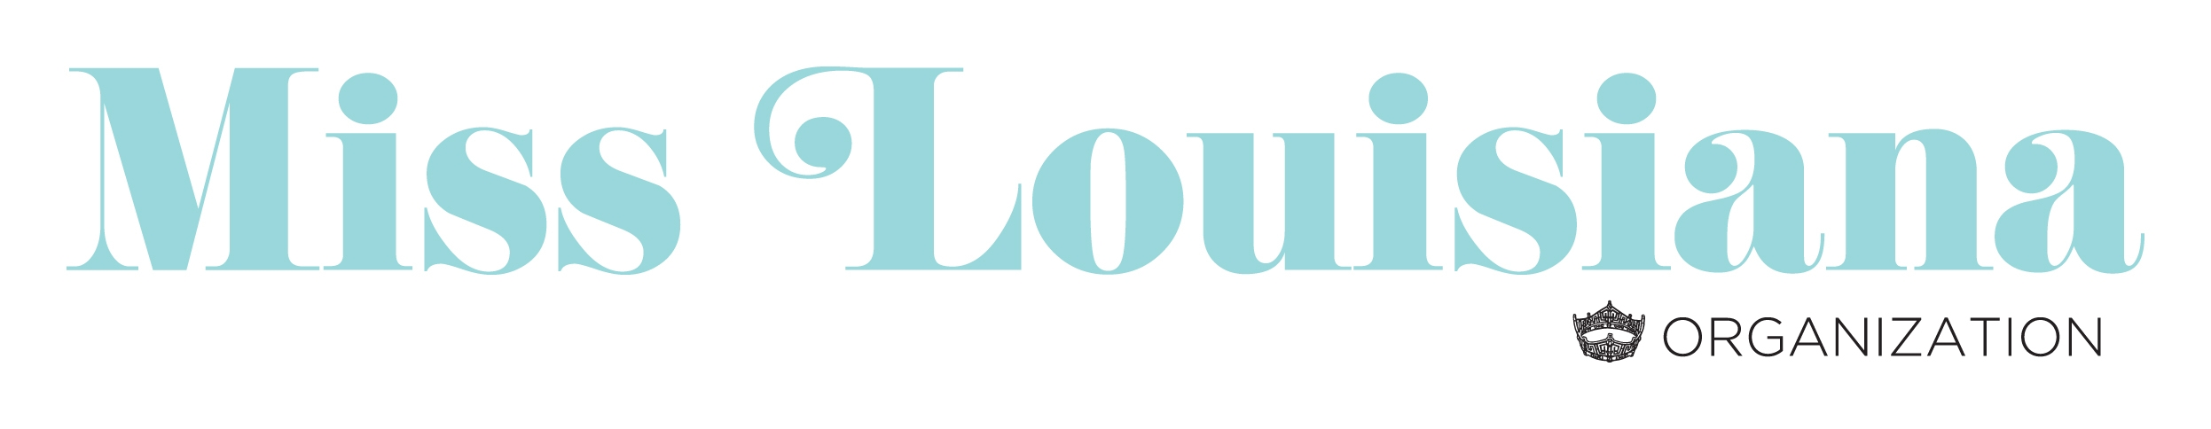

Official Crowns & Sash

KA Concepts
“Official” Miss America Crown Provider

KA Concepts, Ltd.
(800) 528-4926
3 Somner Drive
Huntington Station, New York 11746
www.TheBestCrowns.com

You may also access information to order crowns from the Miss America resource portal.

The Sash Company
“Official” Miss America Sash Provider

The Sash Company
(877) 443-SASH(7274)
www.thesashcompany.com

Sash’s are not required by the Miss Louisiana Organization. However, if a sash is provided it must be the official sash purchased from The Sash Company.

You may also access information to order a sash from the Miss America resource portal.

