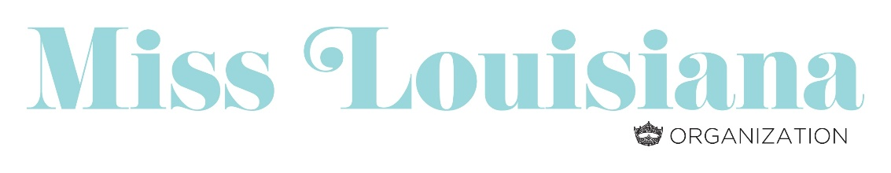
INVOICE

Miss Louisiana Scholarship Organization
Licensing Agreement Fee

State Licensing Agreement for Miss & Teen Preliminary. . . . . . . . . . $ 300.00

The Licensing Agreement entitles the local preliminary to hold both a Miss & Teen
pageant for one fee. Second and third titles may be awarded with no additional
licensing fee, however, pageants must be held at the same time and location. You must
award a minimum of $250.00 cash or in-kind scholarships to each title awarded as well
provide an official Miss America local crown for each title awarded.

Licensing Agreement fees are due within 7 days of your preliminary. Licensing
Agreement fees not paid within 7 days of the pageant will be assessed an additional
10% per month for each month the fee is delinquent.

Please make check payable to the Miss Louisiana Scholarship Organization and remit
via PayPal to:

Miss Louisiana Scholarship Organization
www.misslouisiana.org

